**Beet Seed**

**Task 1. Bug Reports.**

<https://olhabodnar.atlassian.net/browse/BR-1?atlOrigin=eyJpIjoiZjRjZmJhMDk3YzcyNGM1NzkxMmM1MGVjMTUxNGVhNjUiLCJwIjoiaiJ9>

<https://olhabodnar.atlassian.net/browse/BR-2?atlOrigin=eyJpIjoiZWEyOGNjNmZhYWIxNDQ4OWIwNTkyN2I2YmIwOTcwNzIiLCJwIjoiaiJ9>

<https://olhabodnar.atlassian.net/browse/BR-3?atlOrigin=eyJpIjoiYjkwYWU2ZjI5YjNlNGVlN2FjZjUzMTczNTMzMWY4OGIiLCJwIjoiaiJ9>

**Task 2. Display difference + HTML and CSS files and screenshots.**

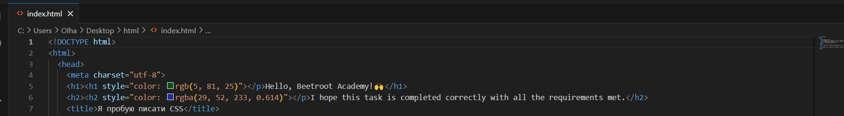

*See the “body.png” file in the folder.*

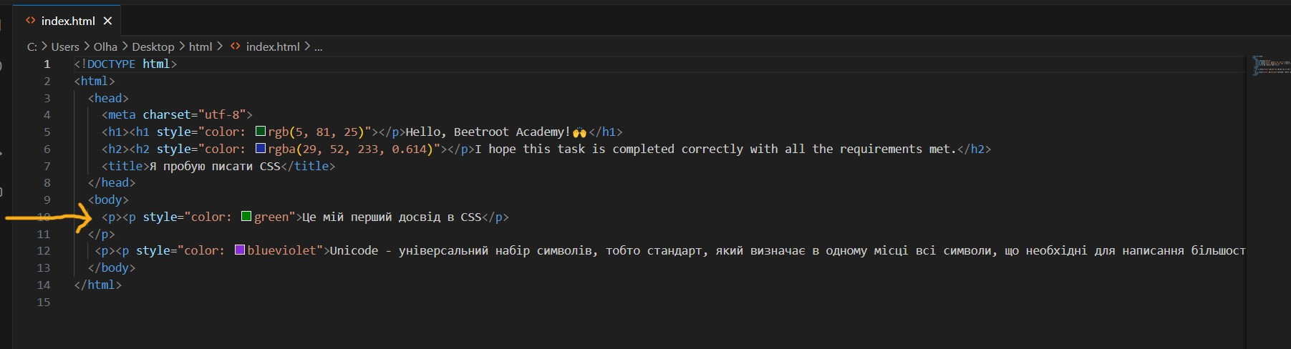

*See the “body element inline style.png” file in the folder.*

*For the external CSS file go to the “html+external CSS file” folder.*

*(The files and screenshots for the task can be found in the folder* [*Lesson 14. H/W Olha Bodnar*](https://drive.google.com/drive/folders/1aNYDlCYvezO76EdHHUiaI70auODnlvVd?usp=drive_link)*.)*

After completing the task, the file was then opened in three different browsers: Google Chrome, Firefox, and Microsoft Edge.

All three were displaying the file almost identically, with only Firefox displaying the colors with stronger saturation.

More differences could be spotted when opening the dev tools.

For Google Chrome, the dev tools windows were displayed on the right side. Firefox displayed dev tools at the bottom of the page; Microsoft Edge displayed the dev tools as well to the right side, yet the styles window was displayed at the bottom of the window.

**Beet Sprout**

Please see the attached screenshots in the folder [*Lesson 14. H/W Olha Bodnar*](https://drive.google.com/drive/folders/1aNYDlCYvezO76EdHHUiaI70auODnlvVd?usp=drive_link)*,* the subfolder“Beet Sprout: Charset.”